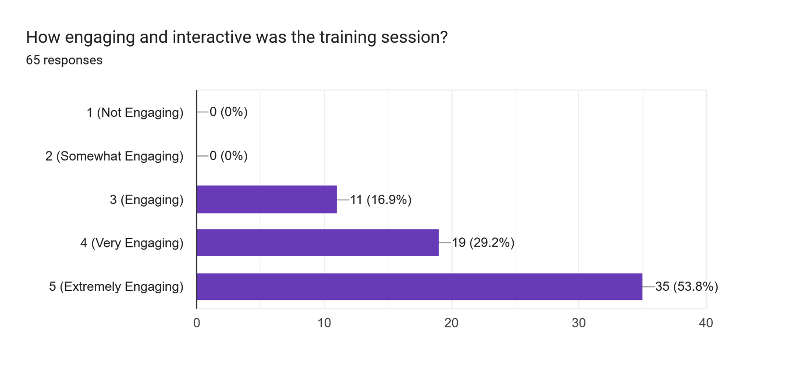

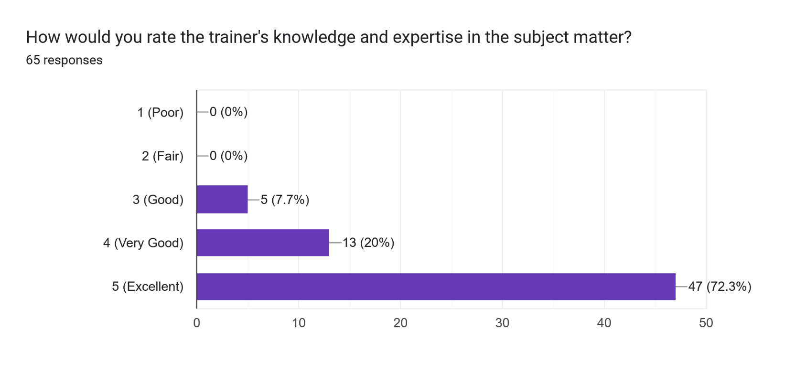

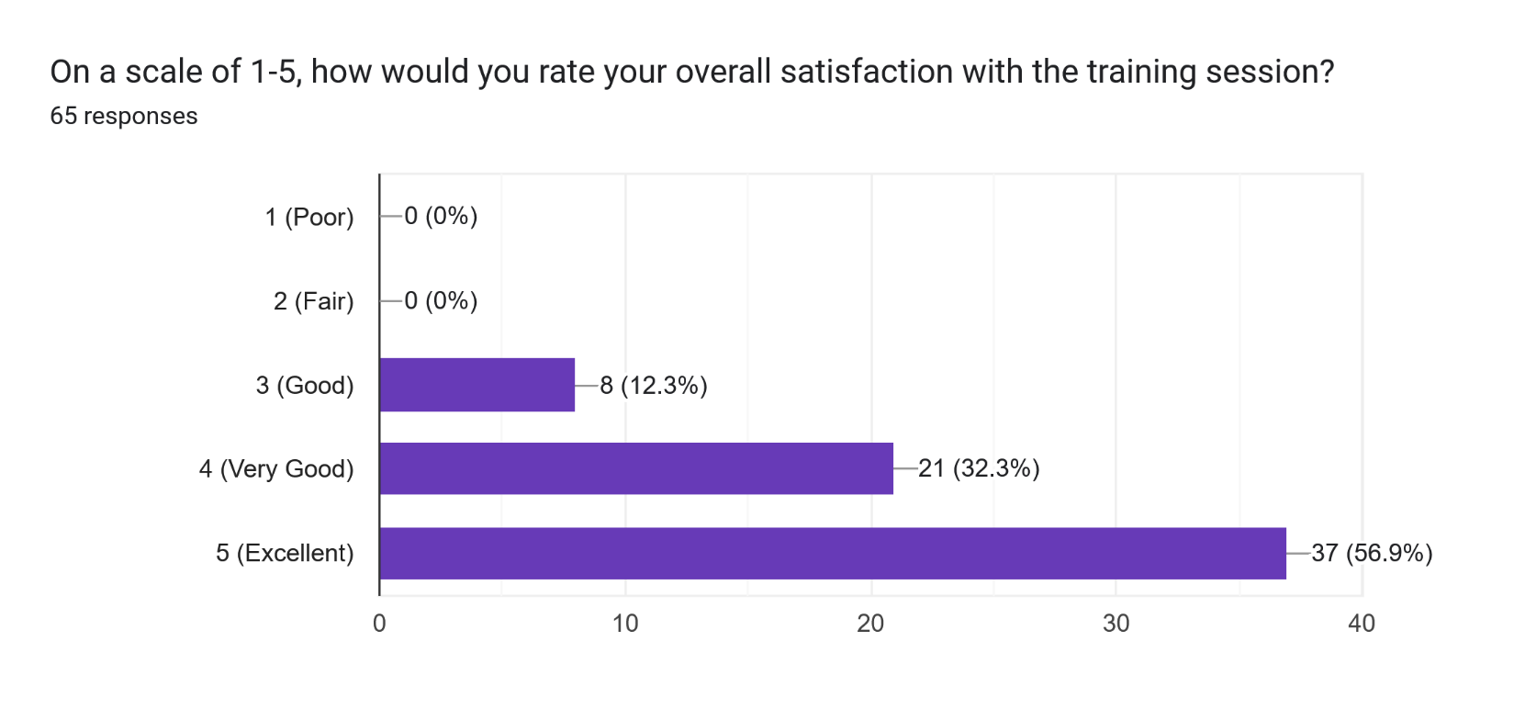

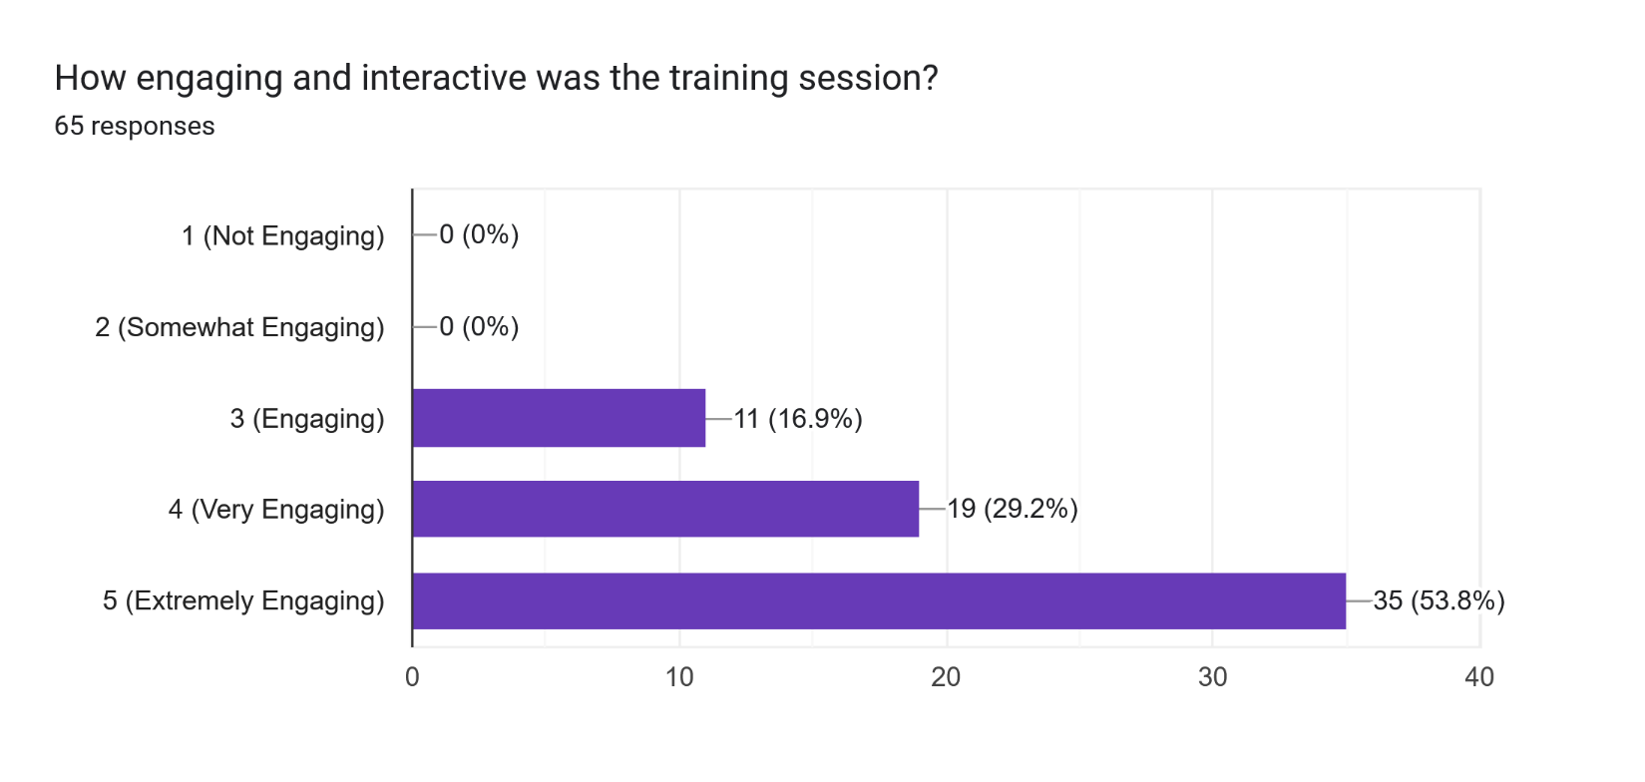

I enjoyed the Training. thank you. - James Paulson

The instructor was good. He had a pretty good knowledge of safety and health. I will highly recommend to everybody if they want to do training for safety and health, go with this one. – Paras

The instructor explained everything well. It was interesting. – Singh

It was amazing and knowledgeable. – Skraikot

Everything was good overall. Knowing that we needed to access some materials for some questions would have been helpful. But overall, very good - Bakuska